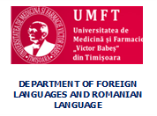

WORKSHOPS FOR ROMANIAN AND FOREIGN STUDENTS
Timișoara, 15 and 17 April 2019

Please complete the registration form and send it to one of the addresses by March 31st, 2019:
frinculescu.iulia@umft.ro
or
staicu.simona@umft.ro

REGISTRATION FORM

Surname:
First name:
Specialization/Major in:
Year of study:
E-mail address:
Title of the workshop
Title of the presentation

